Department of Computer Engineering

Practical - 10

Practical Title: Secure Login/Logout with Sessions, Role-Based Access, Timeout, and Remember-Me Token

Problem Definition: Develop secure login and logout functionality using PHP sessions. Verify password using password_verify(), regenerate session ID after login, restrict dashboard access, implement role-based redirection, session timeout, and optional secure remember-me token.

Theory :
- Are sessions started and destroyed securely?
Yes. Sessions are initialized with httponly: true, samesite: 'Lax' cookie parameters. Logout calls
session_unset(), session_destroy(), and explicitly expires the client-side session cookie.
- Is password_verify() used correctly?
Yes. Authentication runs password_verify($password, $user['password']) which does a timing-attack-safe constant-time comparison against the stored bcrypt hash.

Is unauthorized dashboard access blocked?
Yes. auth_check.php middleware guards all protected routes. Unauthenticated users are redirected to
login.php?msg=unauthorized; wrong-role users get ?msg=forbidden.

Is session timeout implemented?
Yes. $_SESSION['last_activity'] is tracked. After 15 minutes of inactivity (900 s), the session is destroyed and the user is redirected to login.php?msg=timeout.

Are admin and student users redirected to appropriate dashboards?
Yes. Upon successful authentication, administrators are redirected to admin_dashboard.php and students to
student_dashboard.php.

Implementation / Output / Result
if (password_verify($password, $user['password'])) { session_regenerate_id(true); // Prevent session fixation
$_SESSION['user_id'] = $user['id'];
$_SESSION['role'] = $user['role'];
$_SESSION['last_activity'] = time();
header("Location: " . ($user['role']==='admin' ? "admin_dashboard.php" : "student_dashboard.php"));
}

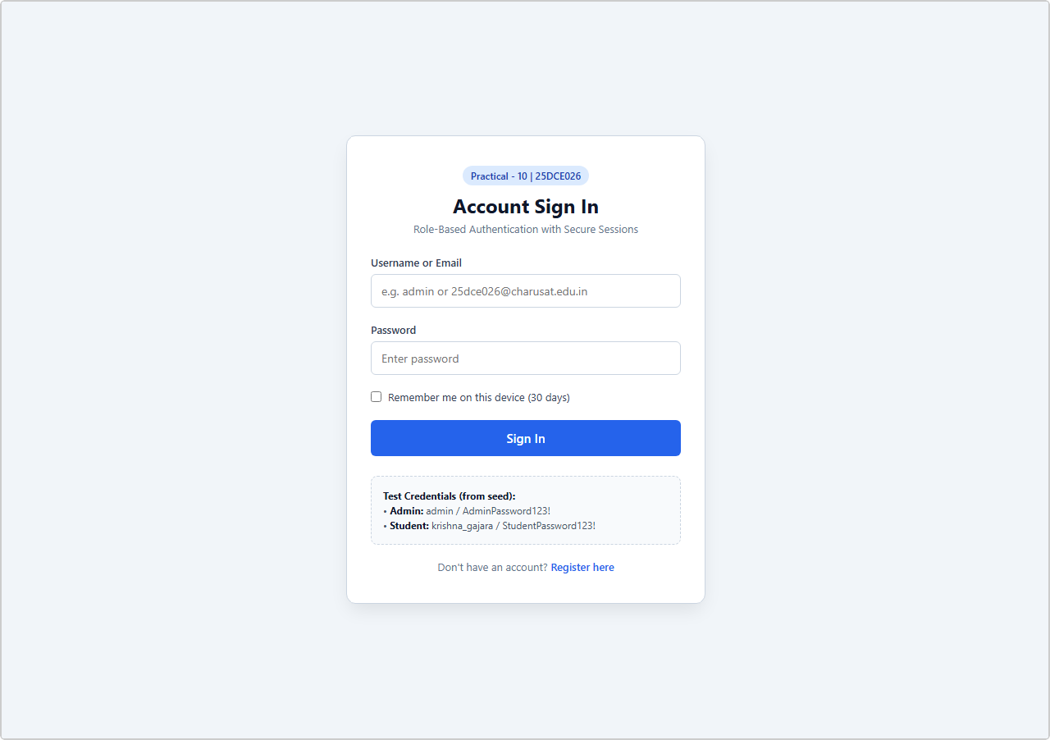
Output 1: Login Form with Remember-Me Option
Live browser screenshot: Sign-In form with Username/Email, Password field, and 'Remember me on this device' checkbox.

Output 2: 15-Minute Inactivity Session Timeout Banner
Live browser screenshot: Info banner — 'Your session expired due to 15 minutes of inactivity. Please log in again.'

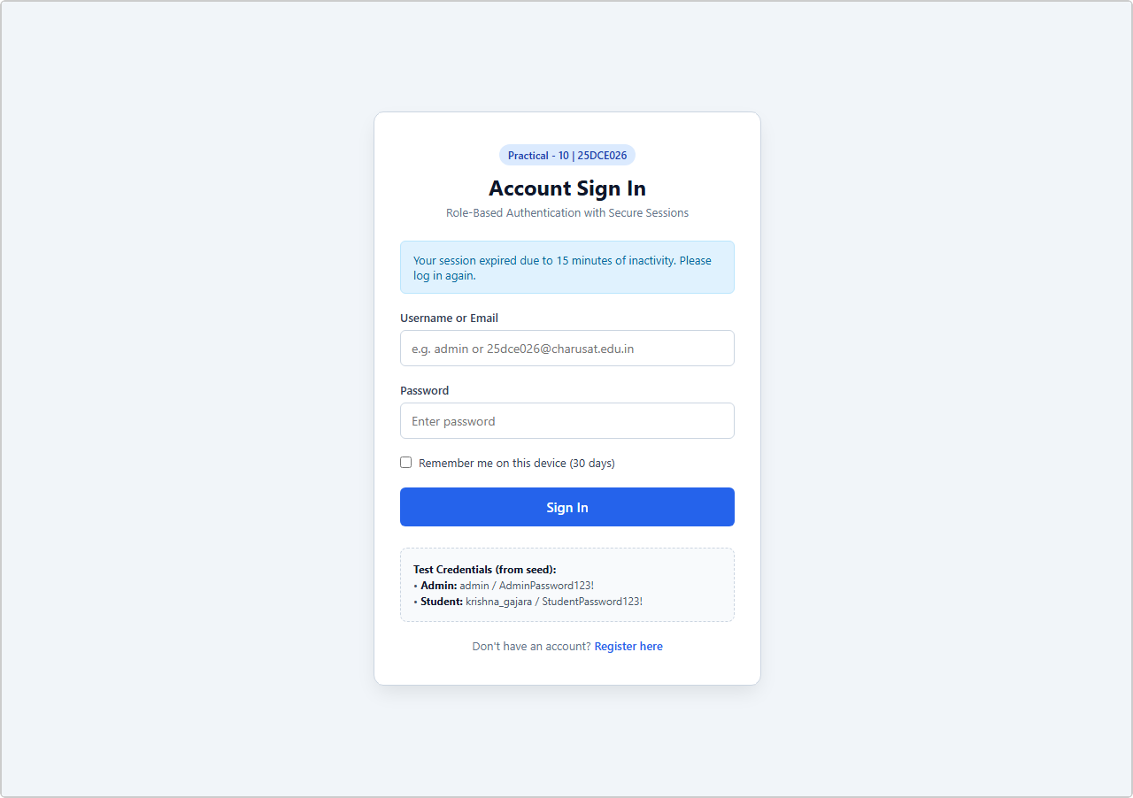
Output 3: Admin Dashboard after Successful RBAC-Guarded Login
Live browser screenshot: Admin dashboard with greeting, role badge, and logout button — only accessible to admin role.

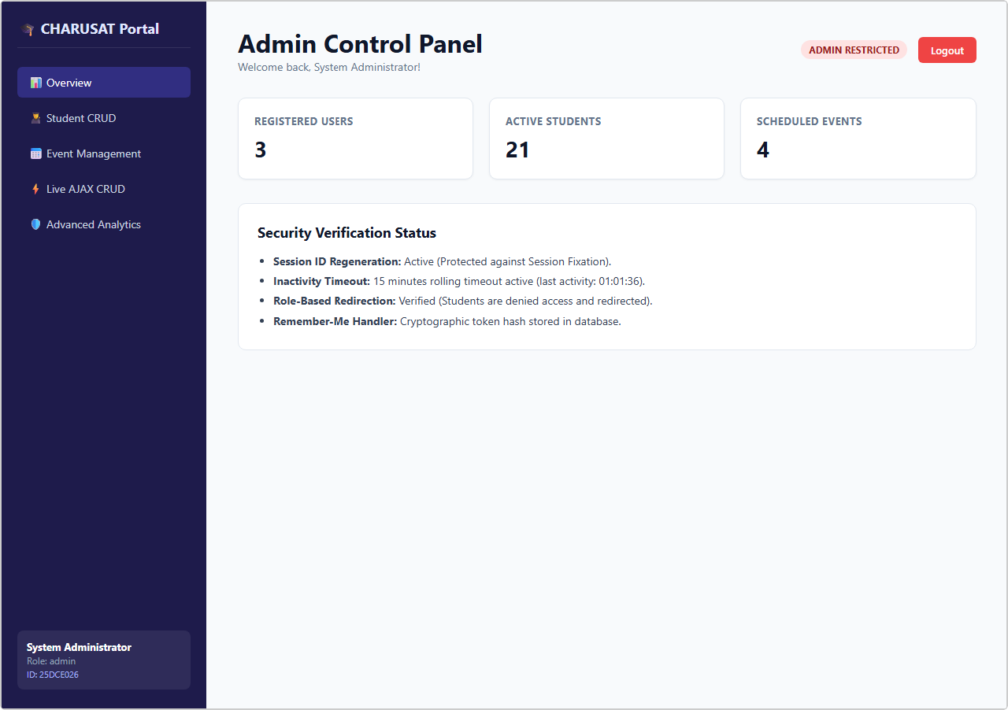
Output 4: Student Dashboard after Role-Based Redirection
Live browser screenshot: Student dashboard showing student-specific content — admin routes are blocked for this session.

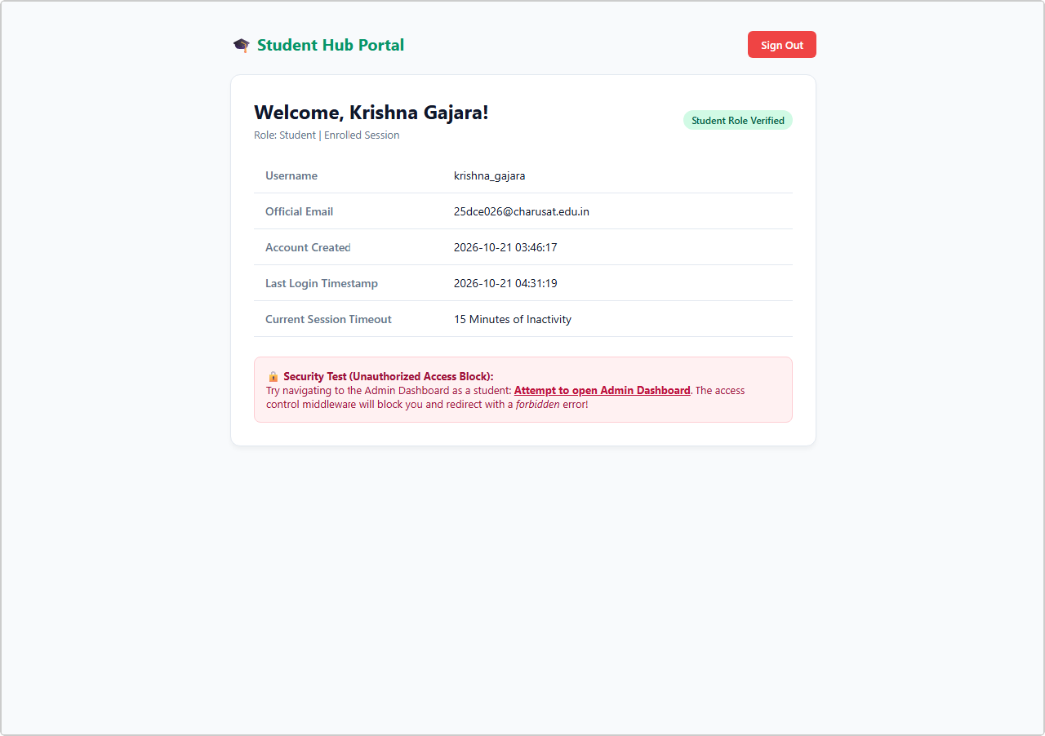

GitHub Repository Link:
https://github.com/bhavya13032007/studenthub/tree/main

Learning Outcomes:
- Implemented secure PHP session lifecycle management and cookie configuration.
- Verified passwords securely using constant-time password_verify() comparisons.
- Protected sessions against fixation exploits using session_regenerate_id(true).
- Designed Role-Based Access Control (RBAC) middleware for restricting protected pages.
- Engineered rolling session inactivity timeouts (15 minutes) with automatic redirection.
- Implemented persistent Remember-Me authentication using cryptographic database token hashes.
- Handled secure session destruction, cookie clearance, and audit logging on logout.

